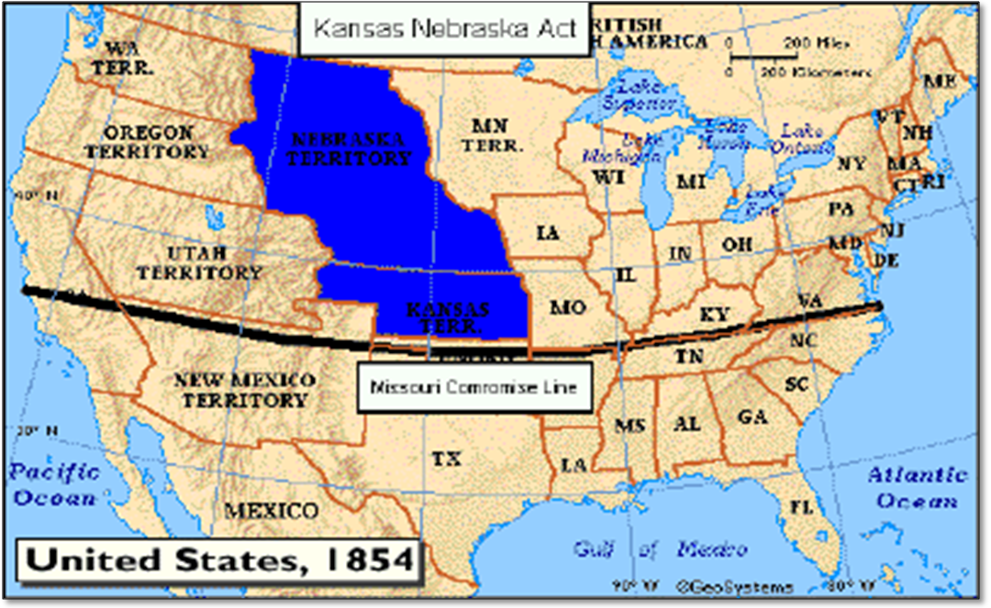
The Kansas-Nebraska Act of 1854 let residents of the Kansas and Nebraska Territories vote on the issue of slavery. Instead of making things better, this Act led to violence called “Bleeding Kansas”

The Kansas-Nebraska Act of 1854 let residents of the Kansas and Nebraska Territories vote on the issue of slavery. Instead of making things better, this Act led to violence called “Bleeding Kansas”

